**Bahria University, Lahore Campus**

Department of Computer Sciences

Lab Journal 01

**(Spring 2024)**

|  |  |  |
| --- | --- | --- |
| Course: | **Operating System Lab** | Date: 2-022-2024 |
| Course Code: | CSL-320 | Max Marks: 20 |
| Faculty’s Name: | Abdullah |  |

Name: _AFFAN AHMAD___________ Enroll No: _03-134221-003______________________

**Objective(s):**

To understand basic concepts of Operating System.

**Tool(s) used:**

Ubuntu, VIM

**Tasks:**

**Task 1 :** What is an Operating System?

An operating system (OS) is a software program that serves as the intermediary between a computer's hardware and its users. It manages and coordinates various hardware components, such as the CPU, memory, storage devices, and peripherals, to enable the execution of software applications. Additionally, an operating system provides a user interface, either through a graphical interface (GUI) or a command-line interface (CLI), allowing users to interact with the computer system, run programs, manage files, and perform other tasks efficiently. Examples of popular operating systems include Microsoft Windows, macOS, Linux, and Unix.

**Task 2 :** Which OS is being used in the Lab?

I don't have access to real-time information, so I can't tell you which operating system is currently being used in a specific lab. However, common operating systems used in laboratory settings include various versions of Windows, macOS, and Linux, depending on the specific requirements and preferences of the lab and its users. If you have access to the lab's computers, you can typically determine the operating system by checking the system settings or by observing the user interface.

**Task 3 :** Install VMWARE and UBUNBTU on your laptops.

**Task 4 :** What is a Virtual Machine? Differentiate between Guest and Host OS.

A virtual machine (VM) is a software-based emulation of a physical computer that runs an operating system (OS) and applications. It allows multiple virtualized operating systems to run concurrently on a single physical machine, known as the host machine. Each virtual machine is isolated from the others and operates as if it were a standalone computer with its own CPU, memory, storage, and network interfaces.

Differentiating between the guest and host OS:

Host OS:

The host OS is the operating system installed directly on the physical hardware of the computer.

It manages the hardware resources of the host machine, such as CPU, memory, disk, and network interfaces.

Examples of host OS include Windows, macOS, or Linux distributions.

Guest OS:

The guest OS is the operating system installed and running within a virtual machine.

It operates independently of the host OS and other guest OS instances, unaware that it's running within a virtualized environment.

Each virtual machine can have its own guest OS, which can be different from the host OS or other guest OS instances.

Examples of guest OS include various versions of Windows, Linux distributions, macOS (on supported virtualization platforms), and other operating systems.

**Lab Grading Sheet :**

|  |  |  |  |
| --- | --- | --- | --- |
| **Task** | **Max Marks** | **Obtained Marks** | **Comments(*if any*)** |
| 1. | 05 |  |  |
| 2. | 05 |  |  |
| 3. | 05 |  |  |
| 4. | 05 |  |  |
| **Total** | **20** |  | **Signature** |

Virtual Box – An Introduction:

Virtual Box is a powerful x86 and AMD64/Intel64 virtualization product for enterprise as well as home use. Not only is Virtual Box an extremely feature rich, high-performance product for enterprise customers, it is also the only professional solution that is freely available as Open-Source Software under the terms of the GNU General Public License (GPL) version 2.

When we describe Virtual Box as a "virtualization" product, we refer to "full virtualization", that is, the particular kind of virtualization that allows an unmodified operating system with all of its installed software to run in a special environment, on top of your existing operating system. This environment, called a "virtual machine", is created by the virtualization software by intercepting access to certain hardware components and certain features. The physical computer is then usually called the "host", while the virtual machine is often called a "guest". Most of the guest code runs unmodified, directly on the host computer, and the guest operating system "thinks" it's running on real machine.

Learn more at [https://www.virtualbox.org](https://www.virtualbox.org/)/

Now we will start Installing Virtual Box in Windows, to install Ubuntu as virtual machine.

# Installing Virtual Box:

You can download Virtual Box version 4.2 from following link. This version is old one but proved to be more stable as compared to latest one.

[https://www.virtualbox.org/wiki/Download_Old_Builds_4_](https://www.virtualbox.org/wiki/Download_Old_Builds_4_2)2

After Download complete of latest version Virtual Box 4.3.26, click on downloaded exe.

**Step1**: Following Welcome screen will appear.

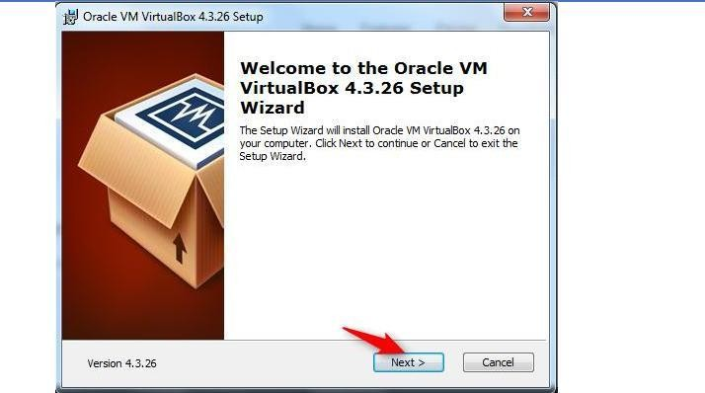

Click “Next” button.

**Step2:**

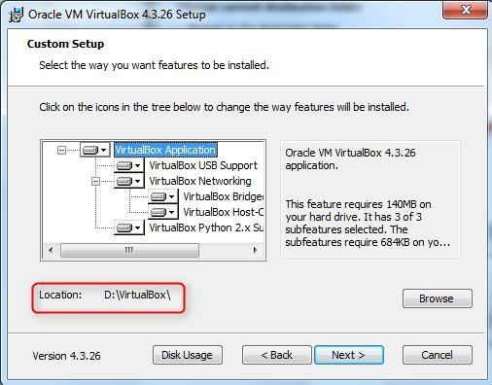

Click Next.

**Step3**: Custom Setup for different features Window is displayed. No need to change anything, just press “Next” button.

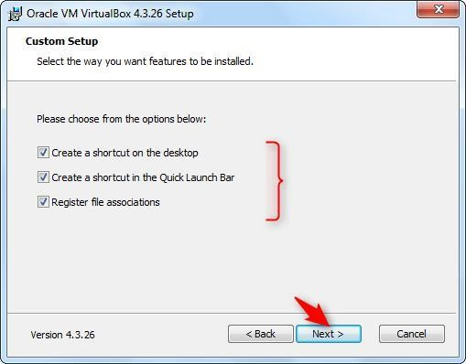

**Step 4:** Warning window is displayed. Click Yes.

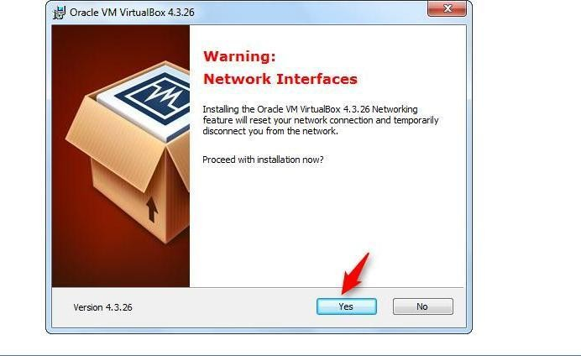

**Step5**: “Ready to Install” window is displayed. Press “Install” button.

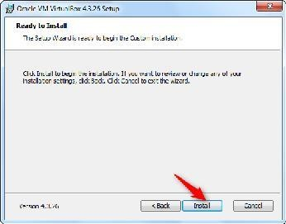

**Step6:** Finally after setup, installation will start and following window will be displayed with status bar.

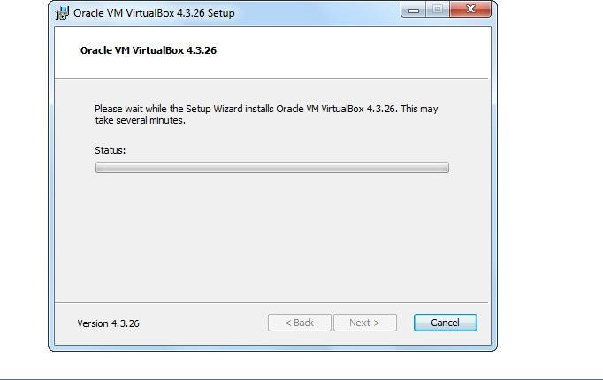

Installation continues…

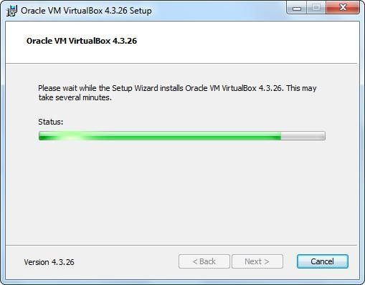

Meanwhile Windows Security will ask for the confirmation of installing hardware. e.g below.

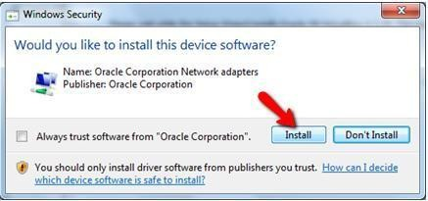

Press Install.

**Step7:** Installation Complete. Press “Finish” button.

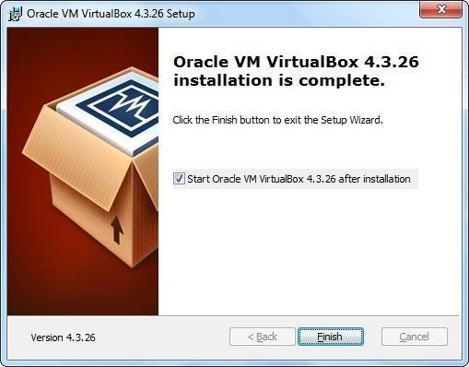

After installation completed, you can find its icon on desktop.

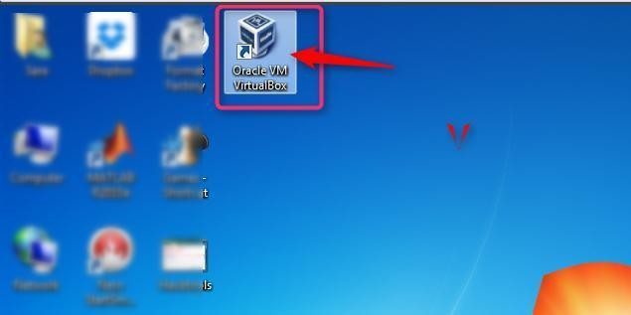

# Setting up Virtual Machine:

**Step1:** Click the Virtual Box icon and following window will be opened.

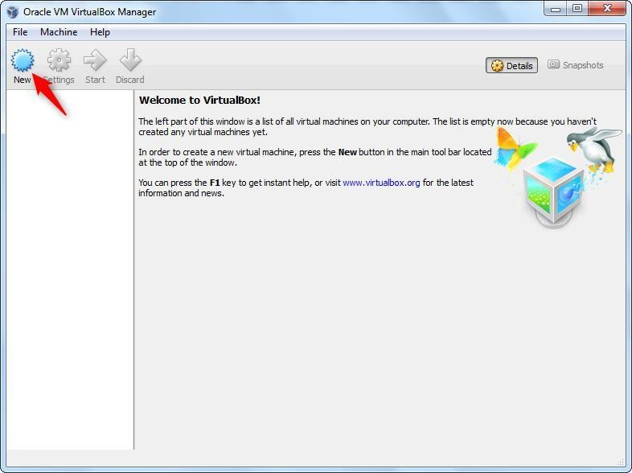

Click on “New” button on top of menu bar.

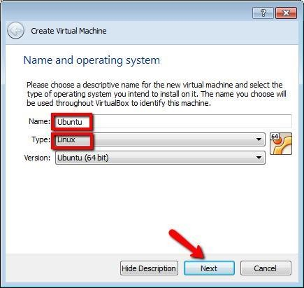**Step2**: Step1 will lead you to setup a new virtual machine.

Following window will be opened to setup virtual machine name and type. Press Next.

**Step3:** By pressing “Next”, following window will be opened to setup memory size.

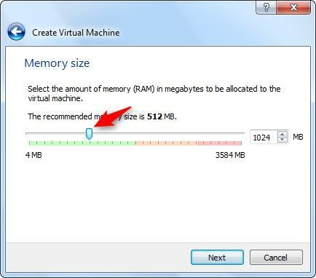

Press Next.

**Step4:** By pressing “Next”, “Hard drive” window will be opened. Select “Create a virtual hard drive now”.

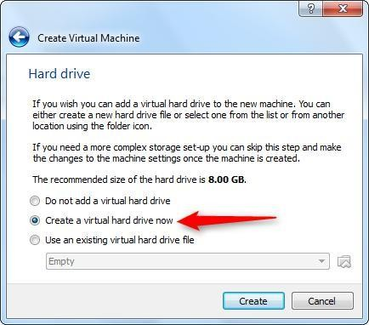

Press “Create” button.

**Step 5:** By default VDI option is selected. Do not make any change and just press “Next”.

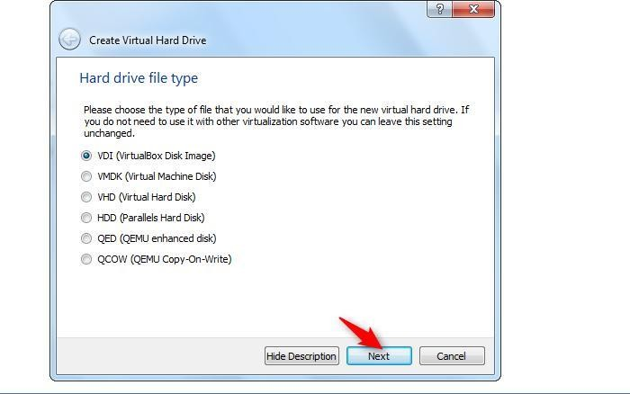

**Step6:** Select “Dynamically allocated”.

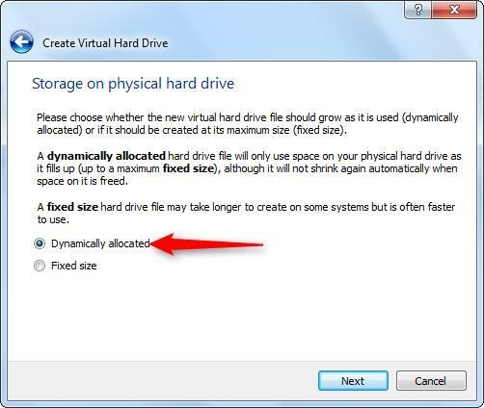

**Step7:** Following window will be opened to setup virtual hard drive size. Here 15 GB is selected but you can select it up to 40GB if free space is available.

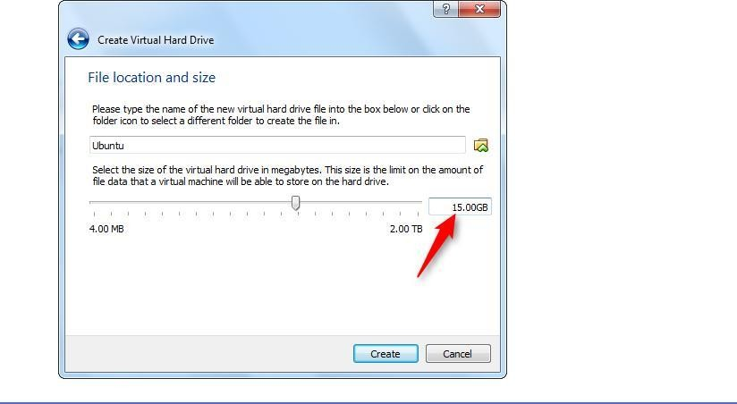

Press “Create” button.

**Step8:** Following window will appear with one virtual machine named “Ubuntu” will be added in left panel.

Click on “Start” button highlighted.

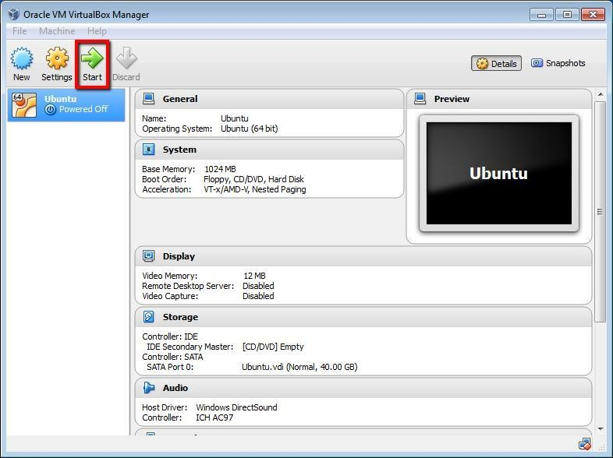

**Step9:** In order to attach ISO image with this virtual machine.

* 1. Click on “Settings” button. Following settings window will open.
  2. Go to Storage Option. Under “Storage Tree” go to Controller: IDE.
  3. Select “Empty” option. By selecting “Empty” Attributes will be changed.
  4. Click on CD icon pointed by arrow in below image.

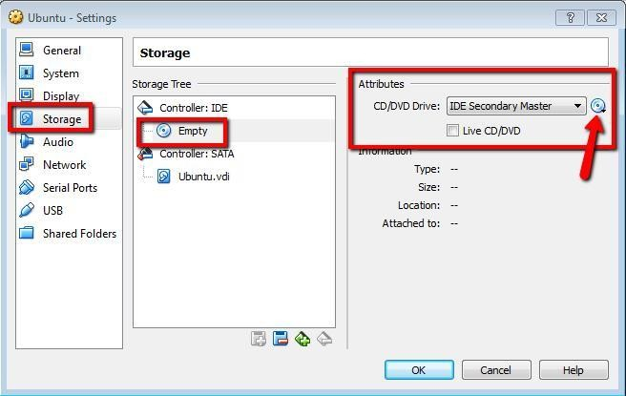

* 1. By clicking at icon of CD, following menu will be displayed.

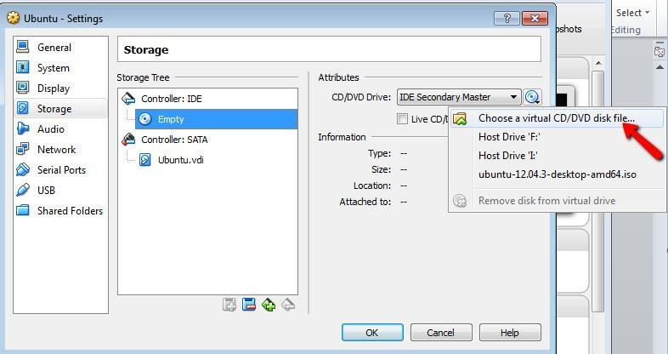

* 1. By clicking on “Choose a virtual CD/DVD disk file… An “Open Window” will appear. Select .iso image and click “Open” button.

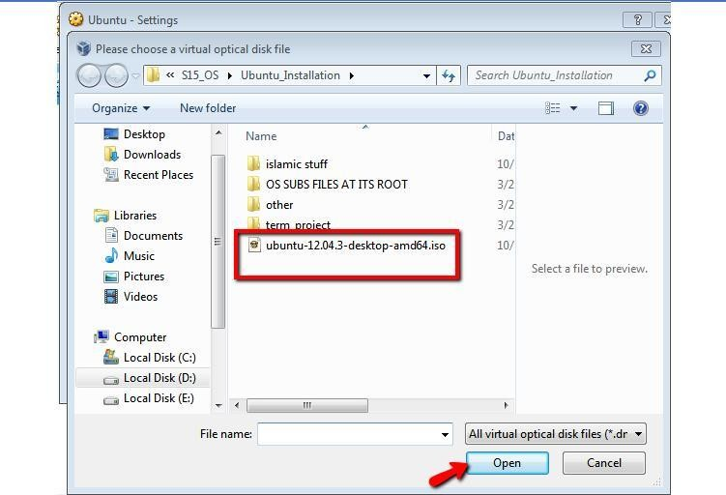

* 1. Now it’s added here. Press “OK” button.

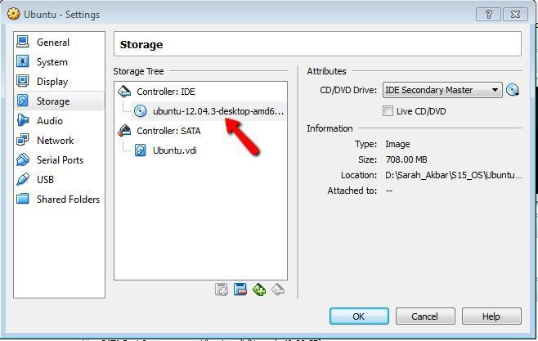

**Step 10:** Click “Start” button and following window will appear.

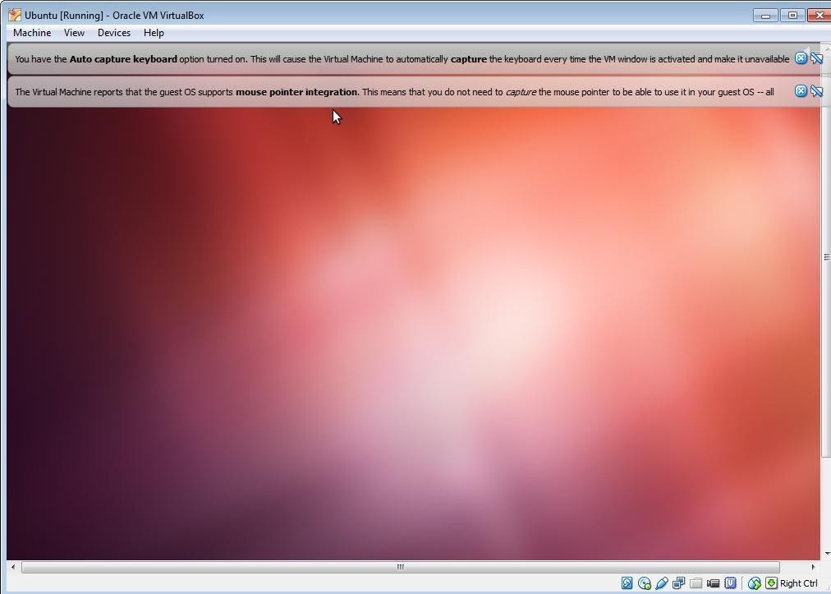

# Installing Ubuntu

**Step1:** Now you will start installing Ubuntu from ISO image just added in virtual machine named “Ubuntu”

When following screen will appear

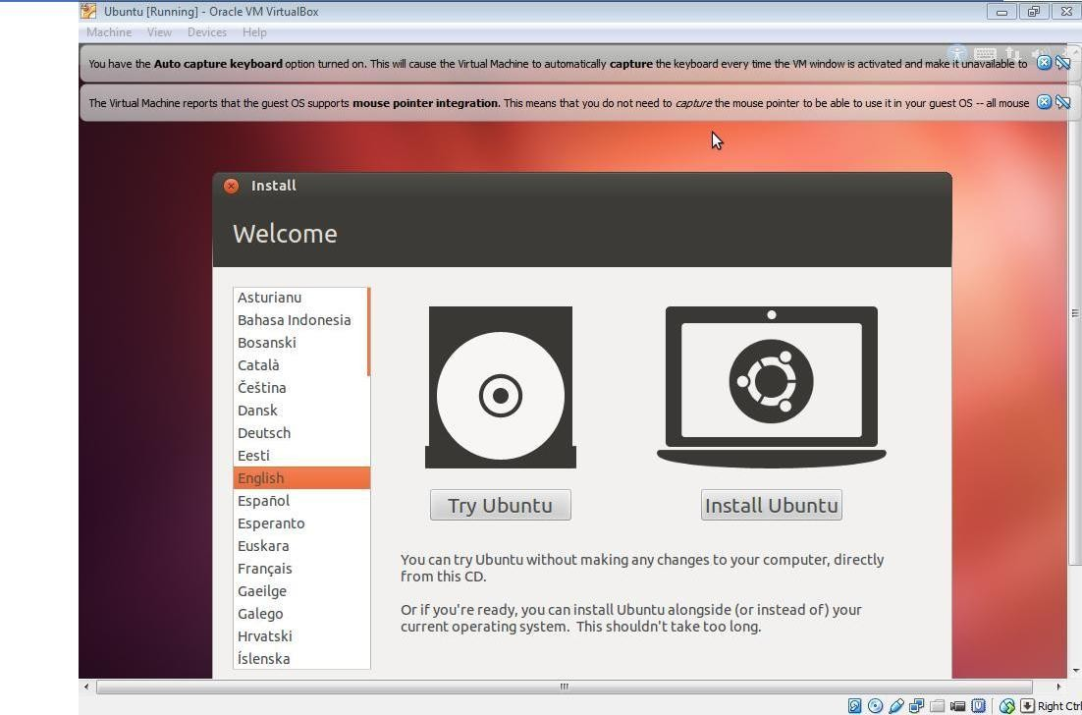

**Step2:** Select “Install Ubuntu” button.

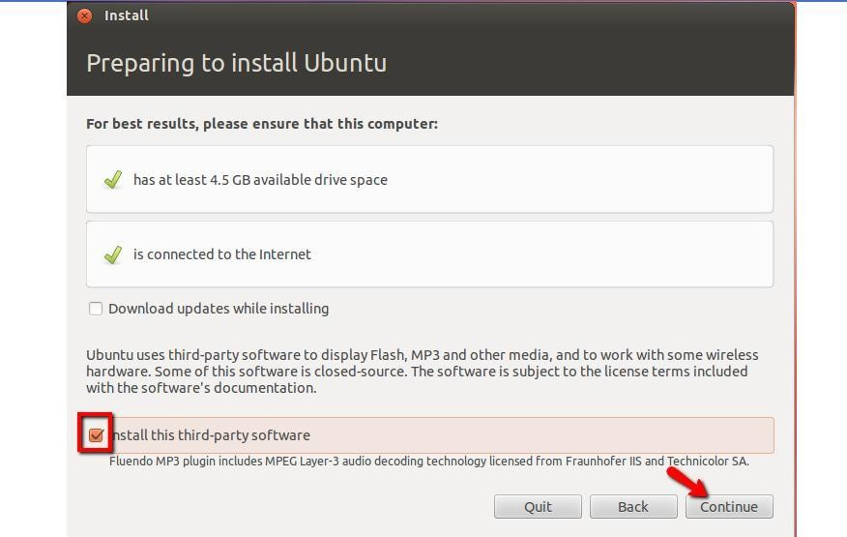

Click Continue.

**Step3:** Select highlighted option below.

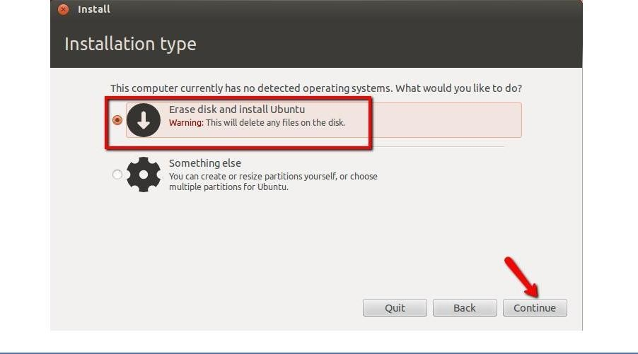

**Step4: Click “Install now”**

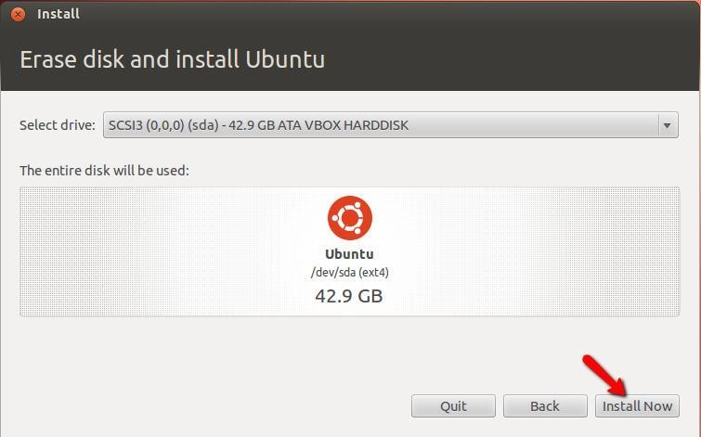

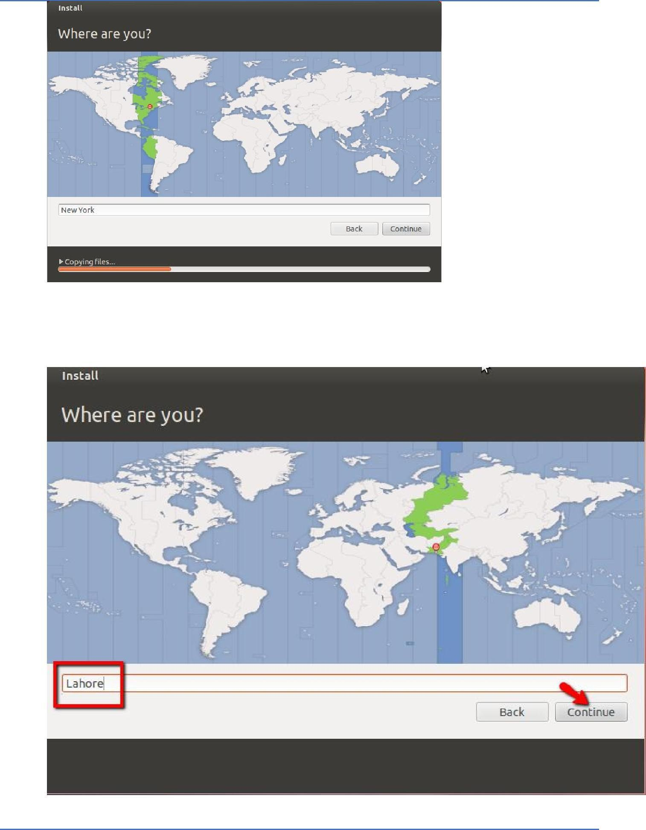

|  |  |
| --- | --- |
|  |  |
| **Step6:** Choose Language |  |

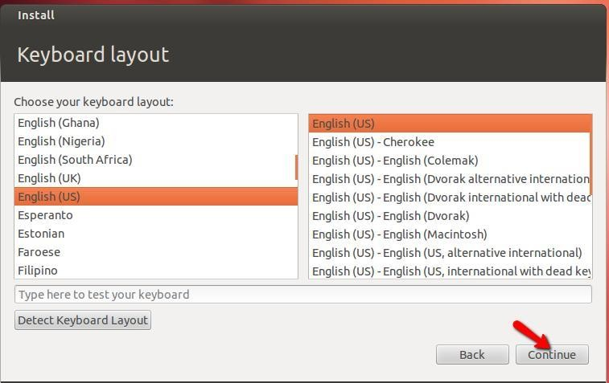

**Step7:** Give username and password information.

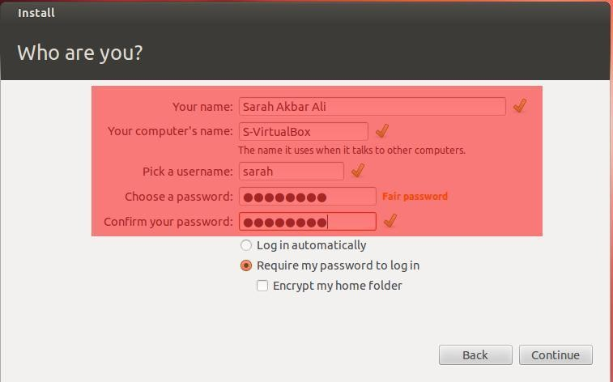

**Step8:** Following welcome window displayed.

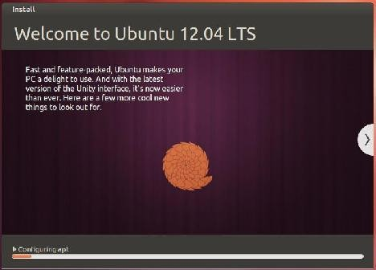

**Step9: Restart system.**

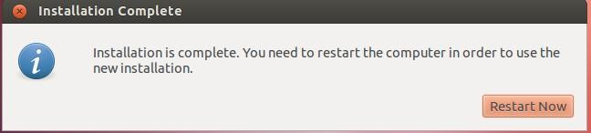

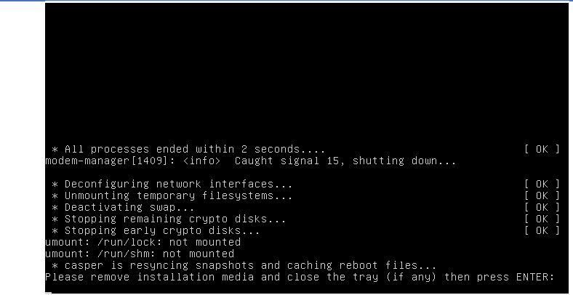

**Step 10:** Press “Enter”. Following screen displayed.Login

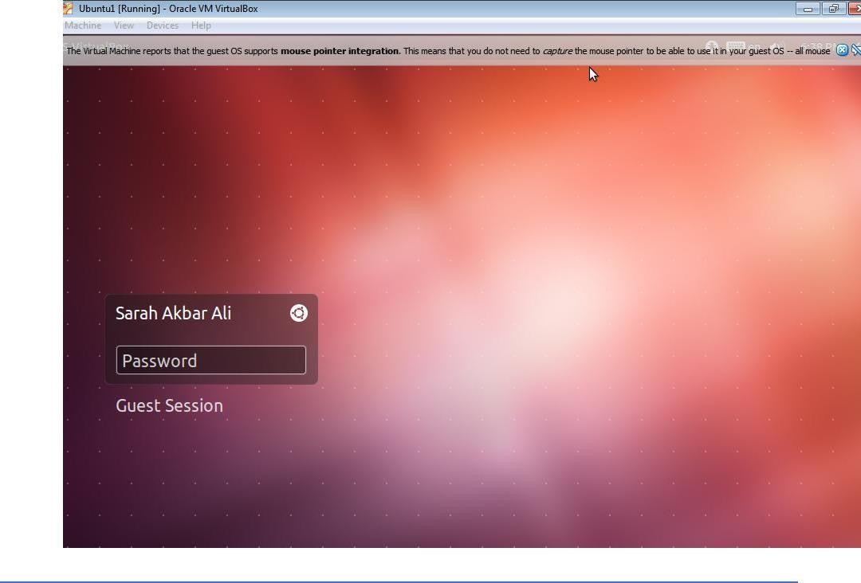

|  |  |
| --- | --- |
|  |  |
| **Step11**: Desktop of Ubuntu displayed. | |

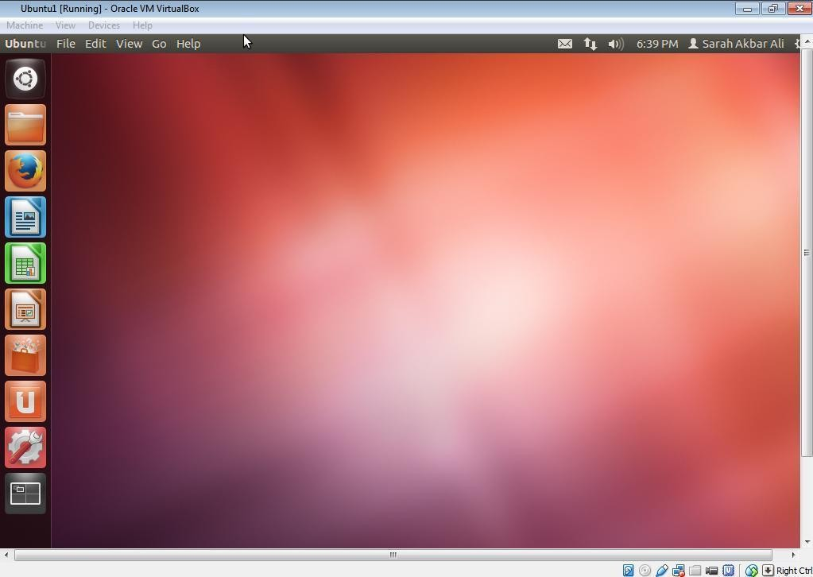

**Step12:** After Installation completed, Go to settings and delete Storage link to iso image.